# **CSYE 7245 - Big Data Sys and Int Analytics**

## **Lab 3 - Apache Kafka**

### **Team Information:**

|  |  |
| --- | --- |
| **Name** | **NUID** |
| Tanvi Gurav | 001306848 |
| Keerti Ojha | 001050173 |
| Priyanka Malpekar | 001302741 |

**Lab Completion Date: 5th February’21**

# 

# 

# About

This lab demonstrates leveraging and implementing Kafka services for static data alongwith real-timeTwitter streaming.



Apache Kafka is a streaming message platform. It is a publish-subscribe based durable messaging system. Kafka is designed to be high performance, highly available, and redundant. It is used to collect, process, store, and integrate data at scale. A messaging system sends messages between processes, applications, and servers.

It’s basic use cases includes:

* Stream Processing
* Messaging
* Website Activity Tracking
* Log aggregation
* Event Sourcing
* Application health monitoring

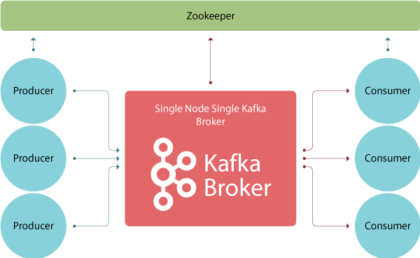

These are four main parts in a Kafka system:

# **Broker**: Handles all requests from clients (producer, consumer and metadata) and keeps data replicated within the cluster. There can be one or more brokers in a cluster

# **Zookeeper**: Keeps track of status of the Kafka clusters (brokers, topics, users)

# **Producer**: Sends records to a broker

# **Consumer**: Consumes batches of records from the broker

# Experiment setup

**Prerequisites:**

1. Installing Oracle Virtual VM Box

**Specifications:**

* 4 GB RAM
* 25 GB Hard Drive
* Downloading ubuntu iso file

**Oracle VM Virtual Box Manager**

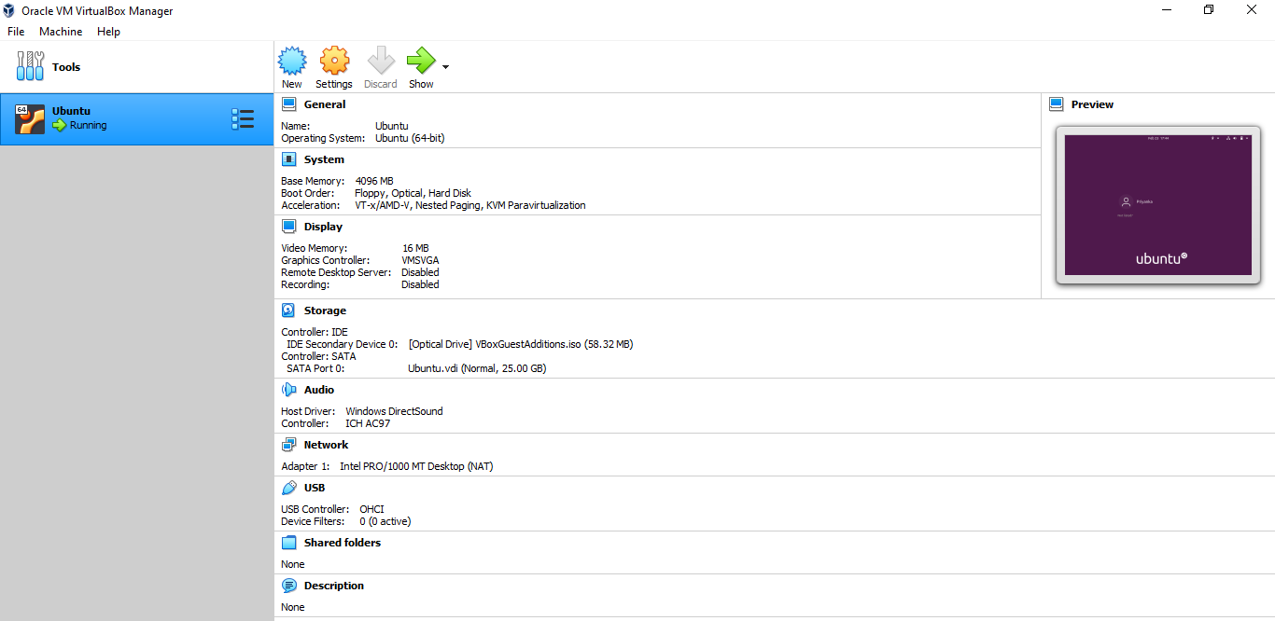

**Login Page**

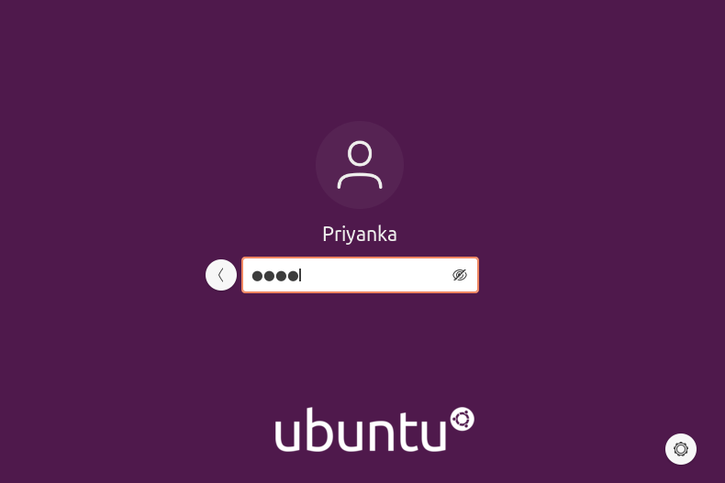

**Requirements:**

1. **Installing Ubuntu Guest Edition**

sudo apt install build-essential dkms linux-headers-$(uname -r)

* Able to copy/paste the contents easily
* Full screen mode available
* Certain in-built headers/packages available for additional functionalities

1. **Installing Python**

Installing the latest version of Python

sudo apt install python3

sudo apt install python3-pip

python3 --version

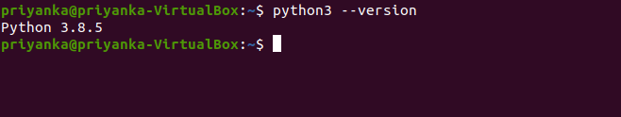

1. **Installing AWS CLI**

AWS CLI helps to access multiple AWS services and functionalities from the command line.

sudo apt install curl

curl "https://awscli.amazonaws.com/awscli-exe-linux-x86_64.zip" -o "awscliv2.zip"

unzip awscliv2.zip

sudo ./aws/install

/usr/local/bin/aws --version

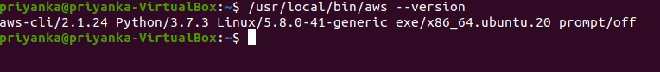

1. **Connecting with AWS**

Connecting the server with AWS account by entering the Access and Secret keys

aws configure

aws s3 ls

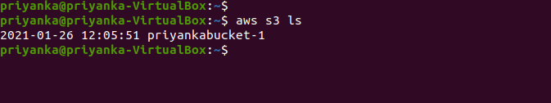

1. **Installing Java jdk**

Java jdk is required for starting the Kafka broker and services

sudo apt update

sudo apt list

sudo apt install default-jre

sudo apt install default-jdk

javac --version

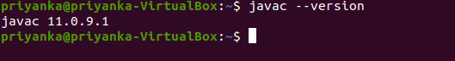

1. **Installing Pycharm in Ubuntu**

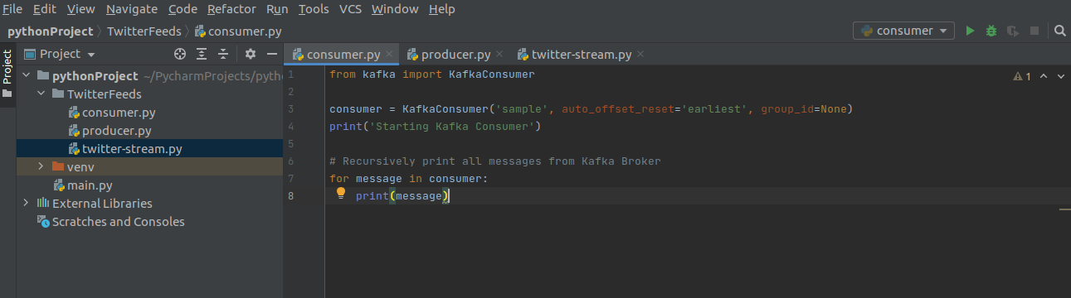

# Test Results

1. **Installing Kafka**

Download Apache Kafka from [here](https://kafka.apache.org/downloads)

Unzip Kafka binaries by using tar -xzvf

pip3 install kafka-python

1. **Starting the Zookeeper service and Kafka broker**

Navigate to the directory where the downloaded files are unzipped and start the Zookeeper service

bin/zookeeper-server-start.sh config/zookeeper.properties

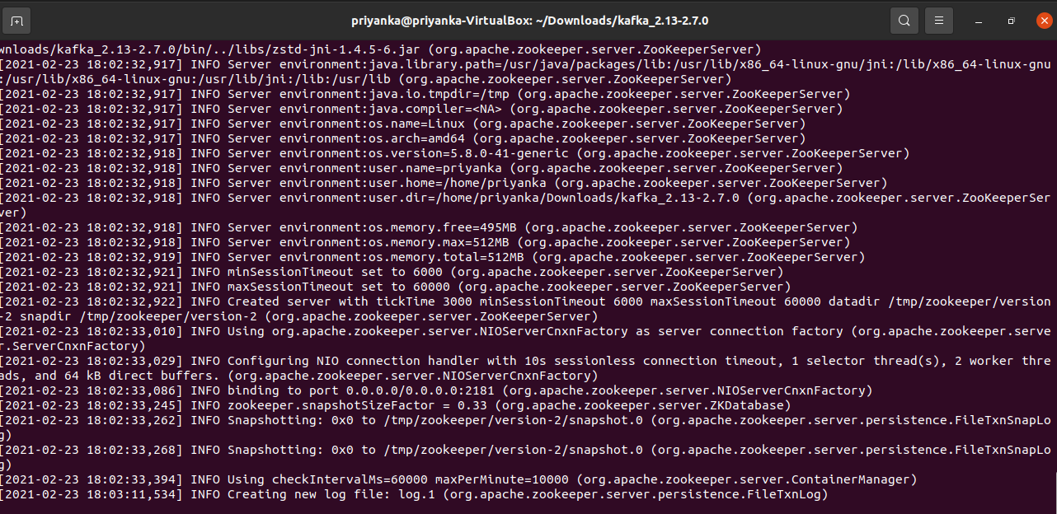

Start the Kafka broker in a new terminal

bin/kafka-server-start.sh config/server.properties

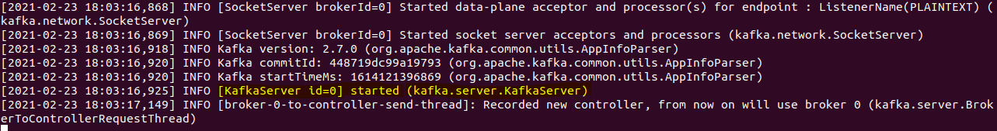

# Use Cases

**Collecting real time sampled tweets from** [**Twitter**](https://github.com/holladileep/CSYE7245-Spring2021-Labs/blob/main/kafka/twitter.com) **and publishing them to our Kafka Broker**

1. **producer.py**

Running the script **producer.py** for generating events

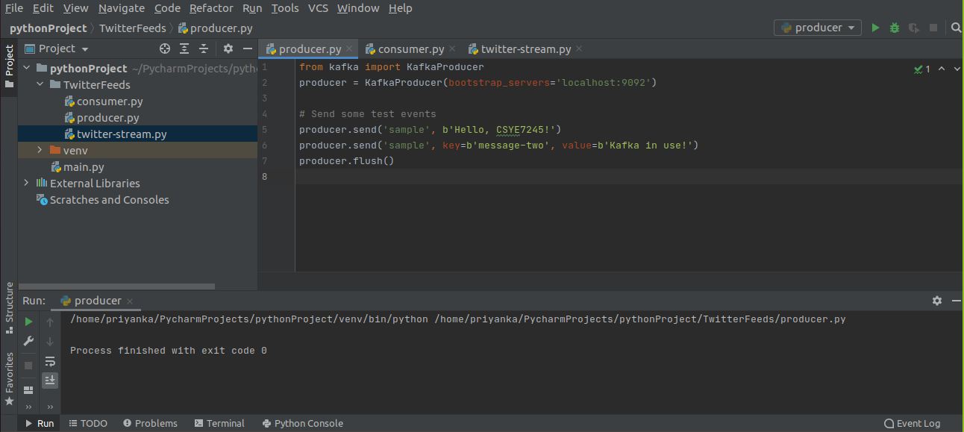

1. **consumer.py**

Running the script **consumer.py** to consume the events published by the producer.

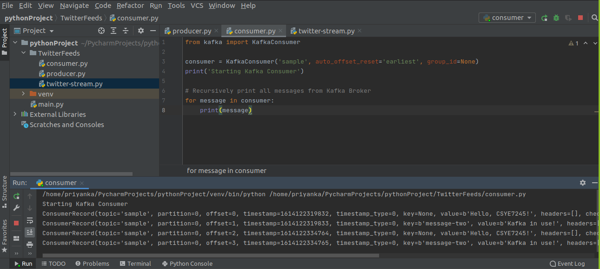

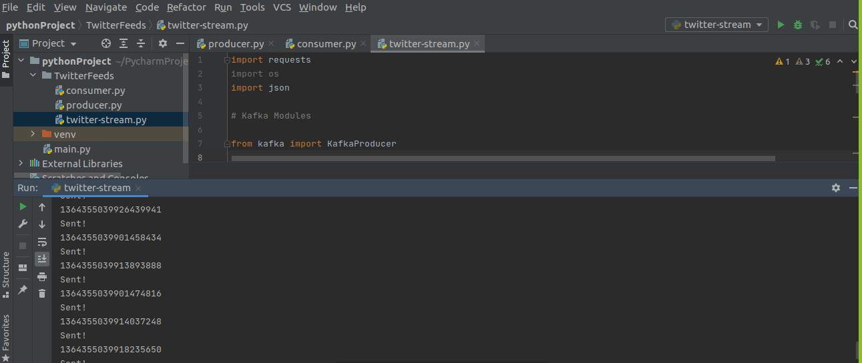

1. **twitter-stream.py**

Using the twitter-stream.py script to fetch tweets from Twitter's API in real-time.

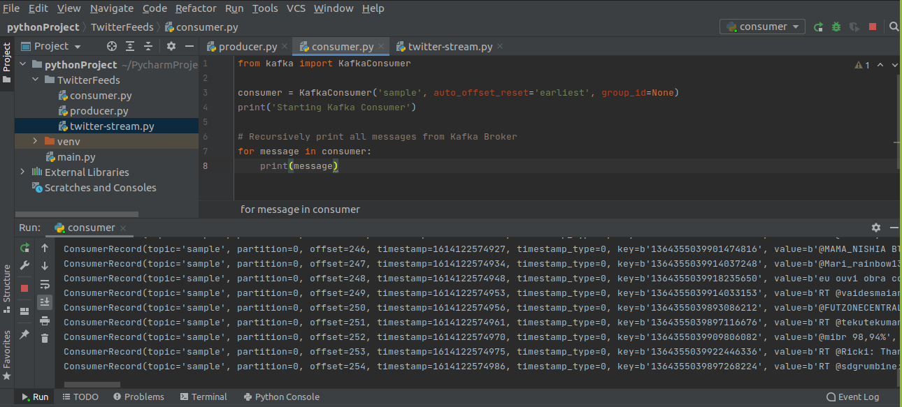

Entering our bearer token in the twitter.py script under the **BEARER_TOKEN** parameter.

Tweets are published to the Kafka Broker.

On running **consumer.py** again, we can see all the published events that are collected by the consumer.

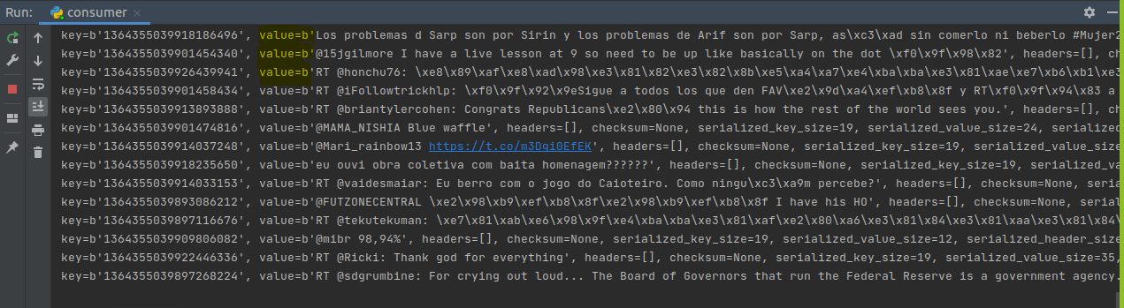

# Lessons learned

1. Learnt configuration of Oracle Virtual Box with Ubuntu operating system
2. Learnt the basic fundamentals of Apache Kafka
3. Implemented real-time data streaming using Twitter API in Apache Kafka

# References

<https://docs.cloudera.com/documentation/enterprise/6/6.1/PDF/cloudera-kafka.pdf>

<https://www.cloudkarafka.com/blog/2016-11-30-part1-kafka-for-beginners-what-is-apache-kafka.html>